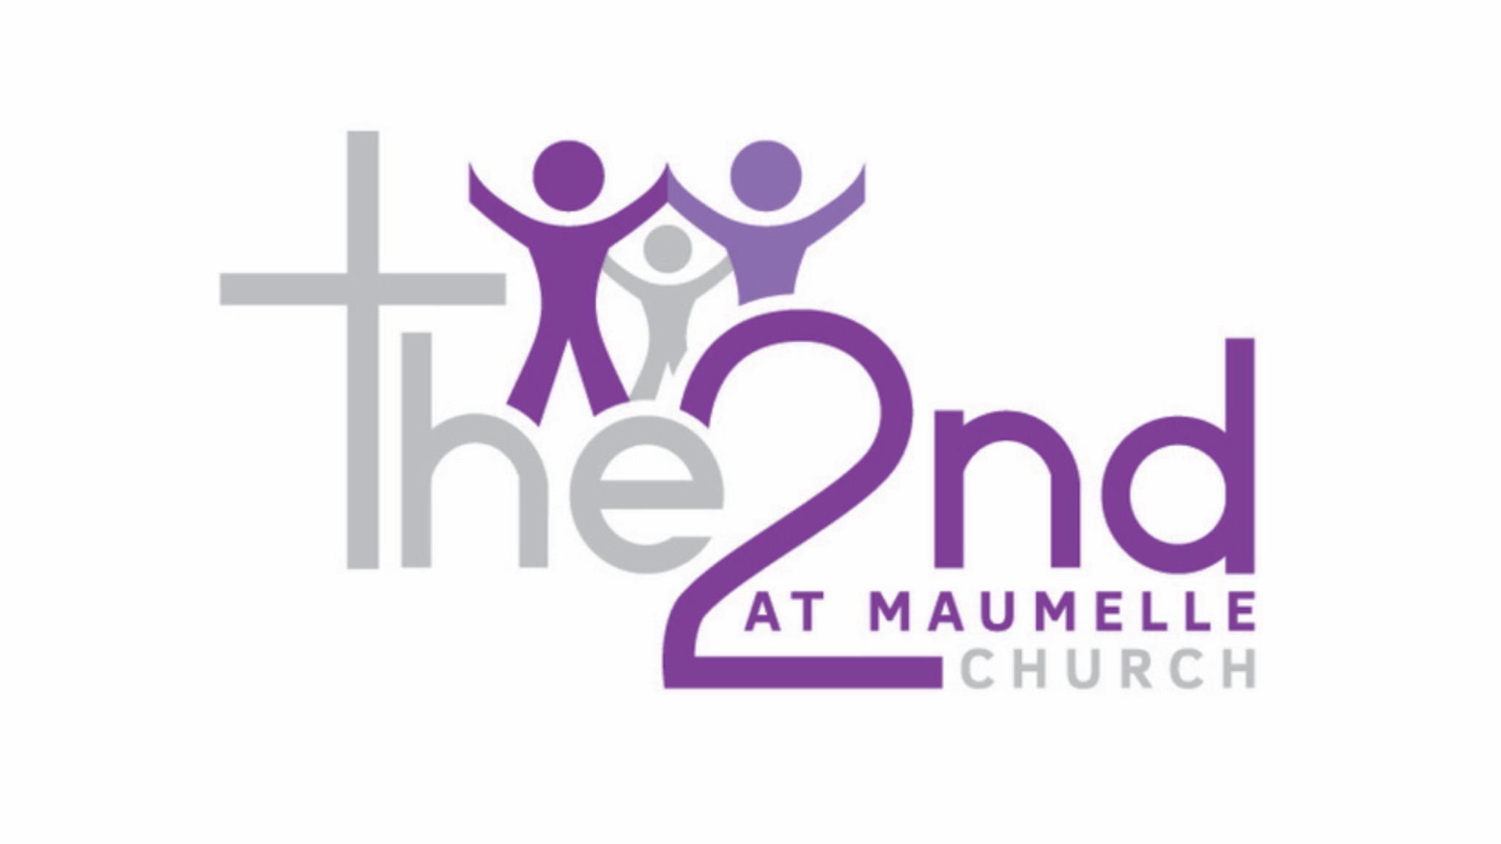
“Worship & The Word”
Taught by: Pastor Kevin A. Kelly

There is a constant war raging. We’ve been teaching how to win the war in our mind! Week 1: we talked comparing thoughts and bringing them into captivity. Week 2: We talked about “Girding up the Loins of your mind”. (Not stumbling over loose thoughts). Last week, Pastor Ahmad dealt with Philippians 4 and how we should be intentional about what we think about.
This evening, I want to focus our attention on Romans 8:5. I’d like to propose to you that we are all living out the manifestation of the mindset that we have. Our realities are the results of our reasoning. I want to propose: If we are going to live a victorious Christian life, we have to reset the carnal mindset that we have developed by default.
(Default is failure to act, or neglect)
Our flesh, assumes a mindset when we don’t take any action.

There is a default mentality that we are innately designed with that develops as we age, through our experiences, our education and our environment.
We all respond and reason from the carnal mindset that we were born with and have developed. And even as Born again Christians, even though we are born again by the spirit, we have a defaulted mindset that has been set based on our human and unholy desires.

Romans 8:5-6 “For those who live according to the flesh set their minds on the things of the flesh, but those who live according to the spirit, the things of the spirit. For to be carnally minded is death, but to spiritually minded is life and peace”
Even though we are called to newness of life (Romans 6:4) and the abundant life (John 10:10), we will live a life of continuous defeat and death, if we don’t get the right mind set. We have to Reset our Mindset!
This evening’s lesson: “How To Reset Your Mindset”

This evening: If we are going to win the war of the mind, I want to consider that there is a carnal mindset, that we all possess by default, that has to be reset to a spiritual mindset, if victorious Christian living is going to be possible.

Our mindsets shape the lives we lead, the actions we take and the future possibilities of the world we live in.
-Mindset is a fixed mental attitude or disposition that predetermines a person’s responses to and interpretation of situations (The Free dictionary)

When we consider the text that we have raised, by Apostle Paul, the message this evening is by default we have a carnal mindset!
To be carnally minded means to cater to the appetites and impulses of our human nature.
By default, we all have a Carnal Response and Reaction based on our Human Reasoning!!
There is an old paradigm of the mind! (The pattern of how we think is based on the paradigm of our mind). Romans 12:2 says we are not supposed to conform to the patterns or paradigms of this world!
The paradigm of the mind has to be shifted or reset, If we are going to live a victorious life in Christ!

Let’s close by looking at Paul’s word in the book of Colossians, as Paul spoke to the Christians at Colosse. He wanted the church to develop a Heavenly mindset, which would deliver them from much of the earthly teaching and tenets.
Paul understood that godly living starts with godly thinking!! (That’s why Satan is always attacking our minds and thoughts!)

Colossians 3:1-2 “Since, then, you have been raised with Christ, set your hearts on things above where Christ is seated at the right hand of God 2 Set your minds on things above, not on earthly things”.
Paul is encouraging the fact that we shouldn’t be thinking at the level of this world! The problem is that a lot of Christians are thinking at the level of this world!

- Reset your Mindset by Developing a life of Continual discipline

The word “set” is an active word. It means it requires discipline and action from us. “You gonna have to set, or Reset”

- Reset your Mindset by Focusing on your position

You can only have an elevated position, if you have an elevated perspective!

- Reset your Mindset by Realizing Your Future In Christ
Whatever you think about your future will affect how you live today.
Verse 4 of Colossians 3 says “When Christ, who is your life, appears, then you will also appear with Him in glory”.

